


GP Enter and View Report
Durnford Medical Practice, Middleton


113 Long Street, Manchester M24 6DL

Introduction
Healthwatch Rochdale (HWR) is the independent voice of Heywood, Middleton, and Rochdale residents. We listen, challenge, and shape local health and social care services.
Healthwatch Rochdale representatives conducted an Enter and View visit at Dunford Medical Practice on 16/09/2025 at 09.00 as part of a planned Quality Visit carried out by the Primary Care Team, GM Integrated Care HMR (Heywood, Middleton, and Rochdale locality).
Dunford Medical Practice is a GP practice in Middleton in the Rochdale Borough with a patient list size of approximately 9,900.

Purpose of Visit:
The purpose of the visit was to review how patients access GP services, including appointment booking systems, accessibility of information, and the overall patient experience including that of the Patient Participation Group (PPG). We spoke with three patients in the waiting area during the visit along with observations and staff engagement. There was a telephone mystery shopper review done the same week looking at appointments etc. This approach highlighted several areas for improvement to services for patients..
Who was involved:
- Moira Auchterlonie - Project Officer HWR
- Tracy Waite - Practice Manager
- Stuart Caldwell – Assistant Practice Manager
- Jackie Woodhall - Primary Care Commissioning Team

Executive Summary
Quick Wins: Here are three quick wins which could improve the service and patients’ experiences at the Dunford Medical Practice.
- To give clearer notices for repeat prescriptions on internal/external post boxes.
- To add call back option to the telephone system.
- To organise the noticeboards with relevant and informative themes e.g. carers’ board, Immunisation board etc.
Key recommendations include establishing a Patient Participation Group, improving repeat prescription instructions, organising notice boards thematically, better patient information around car park issues, and using LED calling screens or TV displays for patient information.
These findings and recommendations have been shared with the practice, and a formal response has been requested in line with Healthwatch’s statutory role. For more information on this please click here.
Booking system:

Telephone System
- Phone answered within 30 seconds with various menu options available.
- First pre-recorded message was that there were no available appointments and to hold for the receptionist to find out about other available services. This was the message on two separate days at 9.30 a.m. and 10.50 a.m. respectively.
- Automated information was about the PATCHS service and how to register for this in person or online. Tests results were available after 3pm that day.
- Queue management -two other callers in the queue and a receptionist answered within three minutes.
- Missing callback feature - patients cannot request a callback while waiting to speak to reception.

Appointment Access
- Practice offers in person booking at the surgery, telephone booking or using the NHS App. PATCHS is not used for booking appointments.
- Routine appointments are booked via the NHS App using Patient Access.
- Video consultations were mentioned on the recorded messages about PATCHS but not clear how to request one.
- Accessing test results had conflicting information. Phone message says available after 3pm. No mention of using PATCHS. The website does not mention telephoning for results.
- Out-of-hours services - On the day of visit, two evening appointments available.

Staffing and Availability
- One receptionist on duty during the visit. Most patients checked in with the receptionist.

Digital Systems
- Online platforms - PATCHS system and NHS App links on website.
- Website functionality - Contains useful information about appointment booking.
- System support - staff are available to help patients set up PATCHS, NHS App.
- Interpretation services available on request.

Observations:

- Access was good to the building and includes wider, automatic doors. The waiting room was clean, tidy with plenty of seating space available for patients.
- The practice car park requires patients to register their vehicle details to avoid a fine from the private company that runs it. Patients must drive through a pub car park, which is managed by the same private company. We were told this company has been sending penalty notices to patients who simply drive through the area.
- The patient toilet in the waiting area was locked.
- There was a repeat prescription box in the foyer with a notice saying to use the post box outside. The outside box did not have any details about being used for prescriptions. Patients can order prescriptions online as well.
- Practice brass plaque needs staff members updating.
- TV/monitor in the waiting area was switched off and the LED call system above reception was not in use on the day of the visit.
- The practice had a "stop and wait" sign to keep patients back from the reception desk. The reception desk has glass barriers requiring patients to speak loudly in an open waiting area and conversations can be overheard. The option for a private room for confidential discussions was not easily visible at reception.
- We observed several patients using the self-check in screen.
- Patients we spoke with in the waiting room, said they usually book appointments face-to-face or over the phone and all commented on very long wait times for appointments.
- Notice boards were not clearly themed or organised e.g. the carers’ information board contained only flu information and no carer-specific content.

Patient engagement

- The practice has not had a Patient Participation Group (PPG) for the past seven years. There is a PPG section on the practice website, and the practice maintains a file of expressions of interest from patients.
- They are looking for guidance on where to start with patient engagement initiatives. The practice manager plans to meet with a successful PPG to understand how it works. She has the Healthwatch Rochdale information pack.

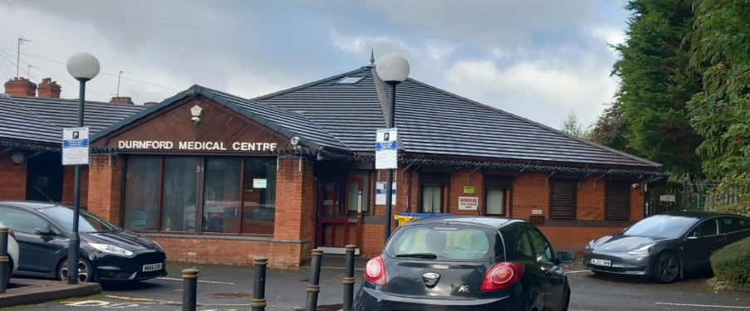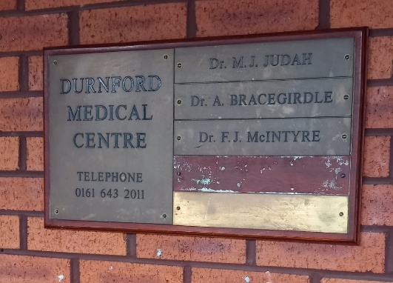
Practice plaque
Car park

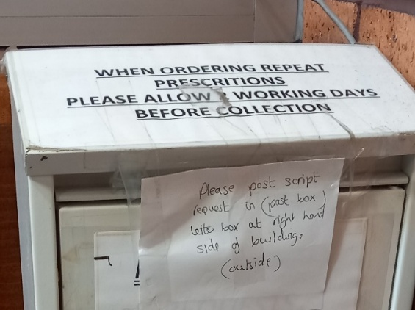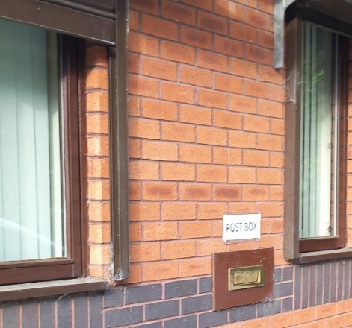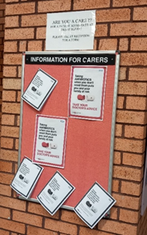
Post box outside
Prescription box in foyer
Carer Notices

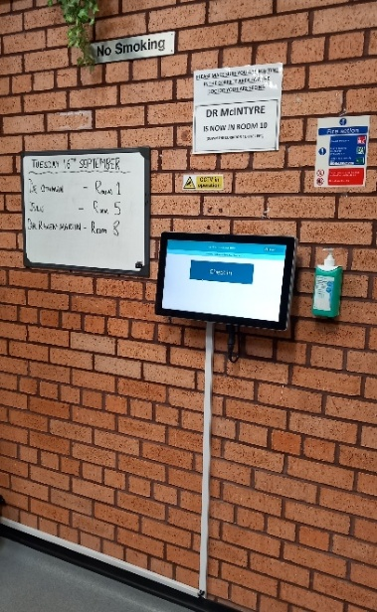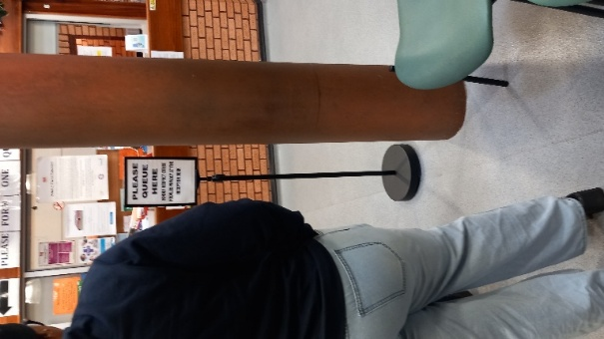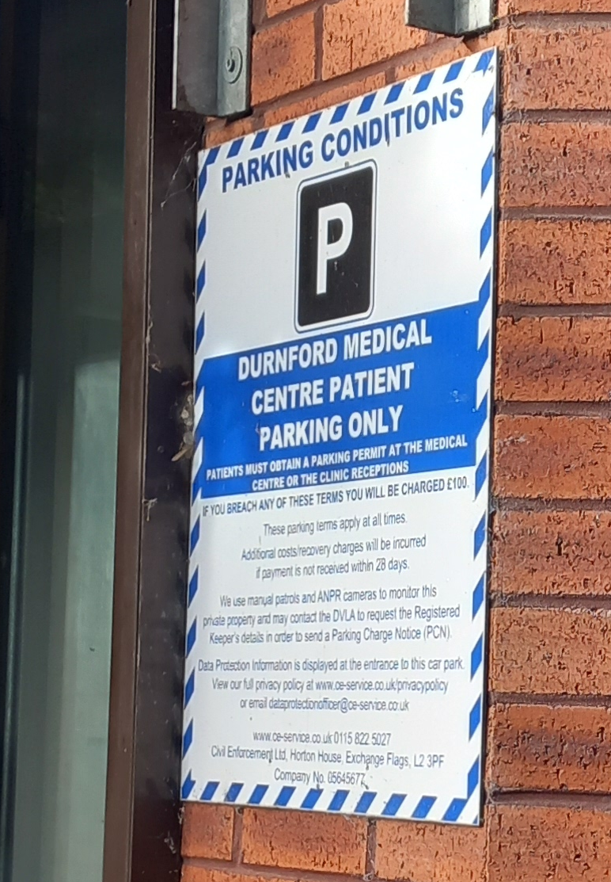
Please Queue Here
Car Park Notice
Self Check In

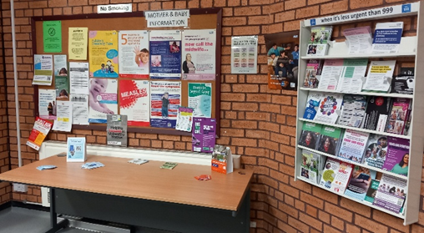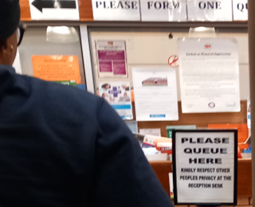
Cluttered Reception Notices
Patient Information

Recommendations and Practice Response
 | Healthwatch Rochdale Recommendation  October 2025 | Dunford Medical Practice  Name & position of responder | Update/Actions/Further comments  Date:
 | To display clearer repeat prescription notices on internal and external post boxes. | Tracy Waite (TW)  Practice Manager | Will reopen the box within reception.
 | To use the TV in the waiting area to provide patient information. | TW | We don’t have a TV in the reception area.
 | Add callback option to telephone system for patients on hold. | TW | Our phone system does allow for a callback function.
 | Organise noticeboards and theme e.g. carer specific information on that board. | TW | I agree. The boards do need to be re-arranged.
 | Poster at reception to inform patients they can request a private space for confidential discussions. | TW | Agree to do.
 | Declutter notices on main reception glass. | TW | We believe this is he best way to get peoples attention to the posters as they are stood in front of them.
 | To provide consistent information (phone message, website) about test results. | TW | Not sure where we are being inconsistent, but the message does say after 3pm.
 | Set up a Patient Participation Group. | TW | Reached out to another practice to observe and then start the process of organising our own.
 | Update practice brass plaque with current clinicians and manager. | TW | Partners have agreed to buy a new plaque.
 | Car park information on website home page. | TW | We will make a reque4st for this to be done.
 | Share report and discuss findings at a future PPG meeting. | TW | Agree.



Healthwatch Rochdale
Tel 01706 249 575
info@healthwatchrochdale.org.uk
www.healthwatchrochdale.co.uk







© Healthwatch Rochdale LTD 2025.
Registered Company Number: 08429721
We confirm that we are using the Healthwatch Trademark (which covers the logo and Healthwatch brand) when undertaking work on our statutory activities as covered by the licence agreement.
If you require this report in an alternative format, please contact us as above.
