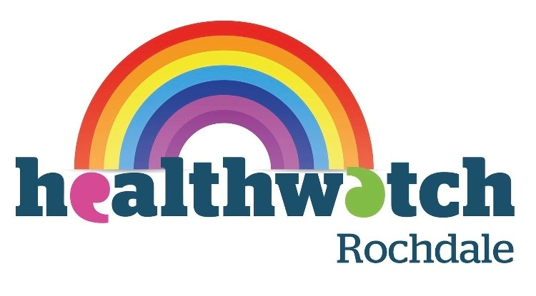
Interested in volunteering with Youthwatch Rochdale?
Volunteer Application Form for 13-18 year olds
Healthwatch Rochdale
No 2 The Esplanade
Second Floor, Suite 2
Rochdale
OL16 1AE

About this application form
We ask all young people interested in volunteering with us as part of Youthwatch Rochdale to complete this application form. The form requests your contact details and a little background information on what you would like to get out of volunteering with Youthwatch Rochdale.
We also provide training to ensure you feel comfortable within your Youthwatch role.
Please email your completed form to info@healthwatchrochdale.org.uk or post your paper version to FREEPOST Healthwatch Rochdale.
We will contact all suitable Youthwatch Rochdale applicants to arrange an informal meeting via Zoom. If you’re under 18 we’ll ask you to get permission from your parents or carer at a later date.

Anyone wishing to volunteer with Youthwatch Rochdale must be between 13 and 18 years old and should either live, work, study or use health/care services in the Rochdale Borough (Heywood, Middleton, The Pennines, Rochdale South or Rochdale North).
If you have any questions or would like to chat about volunteering as a Youthwatch Rochdale member before you complete the form, please contact our Engagement and Volunteer Manager: Naomi Burke naomi.burke@healthwatchrochdale.org.uk or call the Healthwatch Rochdale Office on 01706 249 575.

Personal Details |  |  | Civi ref:
First Name
Surname
Home Address | Street:
Home Address | Town:
Home Address | Post Code
Mobile Telephone Number
E-mail
Date of birth
Age
Your school & year group
Your preferred pronoun (e.g. she)
Which volunteer role(s) are you interested in?
Youthwatch Rochdale Volunteer | Out in the community/ school / college / youth centre or home– sharing information about Youthwatch Rochdale, giving out leaflets & finding out other young people’s views about Health and Social Care in the borough.  You can also get involved in questioning health services to find out what they are doing well for young people in Rochdale and what could be better.  Reviewing flyers/posters to ensure youth friendly and accessible. | Yes /No
Youthwatch 100 | A monthly online survey with a chance to win a monthly voucher for a local business. | Yes/No

Why are you interested in this role(s)?
Please tell us a little bit about yourself and describe what skills and interests you have, It’s helpful to include what you would like to get from a volunteer role with us. Just a paragraph will do!

Why I’d like to volunteer with Youthwatch Rochdale:

Where did you find out about Youthwatch Rochdale?
Access / other requirements /disabilities
 | Wheelchair user |  |  | Hearing loop
 | Large print |  |  | Interpreter

 | Disability |  | Other

Please let us know of any reasonable adjustments we could make to enable you to volunteer with us
Declarations
Data Protection | As part of our volunteer management process we may collect and store sensitive personal data about you. We are required by law to obtain your consent to such data being recorded. It is our policy to store data relating to recruitment procedures for a minimum of 12 months after the date on which a volunteer officially leaves the organisation. Any information of this nature will be treated confidentially.  Sensitive personal data is defined as information relating to any of the following; racial or ethnic origin, political opinions, religious beliefs, trade union membership, health, sexual orientation, offences and/or convictions.  Any information you give in this form will be kept on the Healthwatch Rochdale database and in accordance with the Data Protection Act will not be shared with anyone else without your permission.  For the purposes of the Data Protection Act 1998 the Data Controller at Healthwatch Rochdale is Kate Jones, CEO.

I confirm that the information in this application form is accurate to the best of my knowledge.
Signed
Date

Thank you for completing this application form.
Please return via email to info@healthwatchrochdale.org.uk
or by post to FREEPOST Healthwatch Rochdale
We will be in touch soon!

