


GP Enter and View Report
The Kingsway Practice, Rochdale


285a Kingsway, Rochdale OL16 4AT

September 2025

Introduction
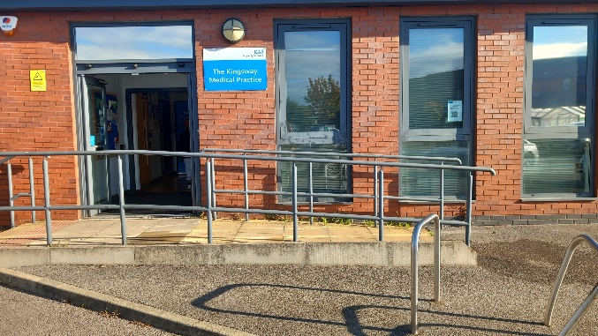
Healthwatch Rochdale is the independent voice of Heywood, Middleton, and Rochdale residents. We listen, challenge, and shape local health and social care services.
Healthwatch Rochdale representatives conducted an Enter and View visit at The Kingsway Practice on 24/09/2025 at 10.00am as part of a planned Quality Visit conducted by the Primary Care Team, Neighbourhoods & Community (Heywood, Middleton Rochdale) NHS Greater Manchester.
The Kingsway Practice is a GP practice in the Rochdale Borough with approximately 4,200 patients.

Purpose of Visit:
The purpose of the visit was to review how patients access GP services, including appointment booking systems, information accessibility, patient engagement and the Patient Participation Group (PPG). There were four patients in the waiting room. It was not possible to speak with them as they chose not to engage. However, observations made in the practice and with staff highlighted areas for improvement.
Who was involved:
- Dr Bodrul Alam - Clinical Lead, NHS Greater Manchester
- Moira Auchterlonie - Project Officer, Healthwatch Rochdale
- Lauren Corner - Senior Practice Manager
- Dr Jonathan Squibbs – Lead GP
- Jackie Woodhall –Transformation & Delivery Lead, Primary Care, Neighbourhoods & Community (HMR) NHS Greater Manchester

Executive Summary
Quick Wins to improve the service and patient experiences at The Kingsway Practice.
- Privacy notices and a ‘Please wait’ sign in reception to improve patient confidentiality
- Ensure the waiting room TV is switched on to promote patient communication, providing key information, health advice, and signposting to services.
- To display "You Said, We Did" board in the waiting room to share actions taken from patient feedback.

Key recommendations include activating the call-back option on the practice telephone system, ensuring the waiting room television is operational and switched on, and organising the noticeboards by theming each board appropriately.
These findings and recommendations have been shared with the practice, and a formal response has been requested in line with Healthwatch’s statutory role. For more information on this please click here.
Booking system:

Telephone System
- We conducted a ‘mystery shopper’ review of the telephone booking system.
- The phone was answered within 30 seconds, and the recorded message mentioned 999 call situations, appointments and repeat prescriptions.
- The message said to call back after 10am to book routine appointments, order prescriptions or check for results.
- Queue management -second in the queue at 9.30 am, fourth in the queue at 2pm. Calls were answered in person after 5 and 4 minutes respectively.
- When on hold there was no call back option for patients. No other messaging when on hold.
- Same day face to face appointments were available in the afternoon.

Appointment Access
- On the morning of the visit, same-day face-to-face and telephone appointments were available to book for the afternoon.
- Patients mainly book appointments by phone, and some book in person at reception. Routine appointments are released after 10 a.m.
- The practice encourages use of the NHS App for booking. Patients can also request appointments via the online PATCHS system. Reception staff triage these requests and confirm appointment dates and times.
- A poster at reception displays the number of missed appointments.
- Extended hours appointments are provided through a Saturday clinic at the practice every six weeks (9:00 a.m.–5:30 p.m.). Locations rotate across practices in the Primary Care Network. Clinics are staffed by two receptionists, two nurses, two healthcare assistants and two GPs. Saturday appointments help working patients access routine services such as blood tests.
- Evening extended hours appointments are available at Kirkholt Practice (6:30–8:00 p.m.), and this practice can book patients directly into these sessions.
- Interpreter services, including British Sign Language (BSL), are available. The practice has approximately ten deaf patients and provides face-to-face BSL interpreters for routine appointments or video interpretation via Silent Sounds for urgent and same-day appointments.

Staffing and Availability
- Male and female clinicians available including GPs and other practitioners.

Digital Systems
- Patients were using the self-check in and were asked by reception to use it.
- Online platforms - PATCHS system listed on website along with the NHS App.
- Website has information about appointment booking with clear wording on how to access via the telephone and online.
- NHS App training was provided across the locality at a recent open day, supported by the PPG.

On the day

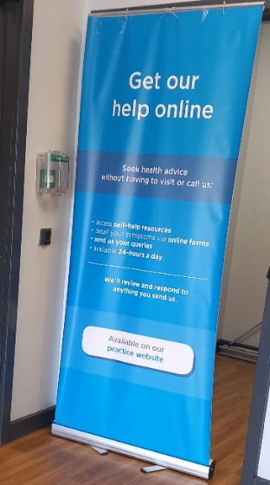
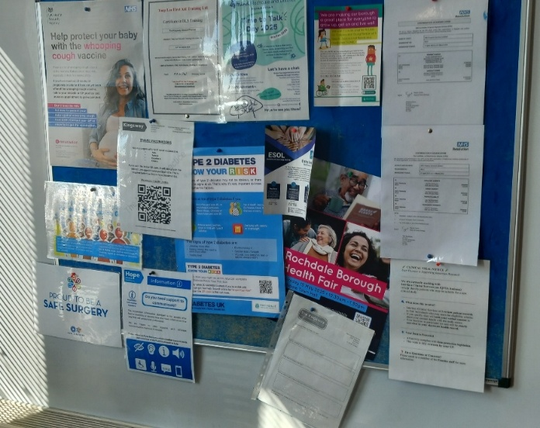
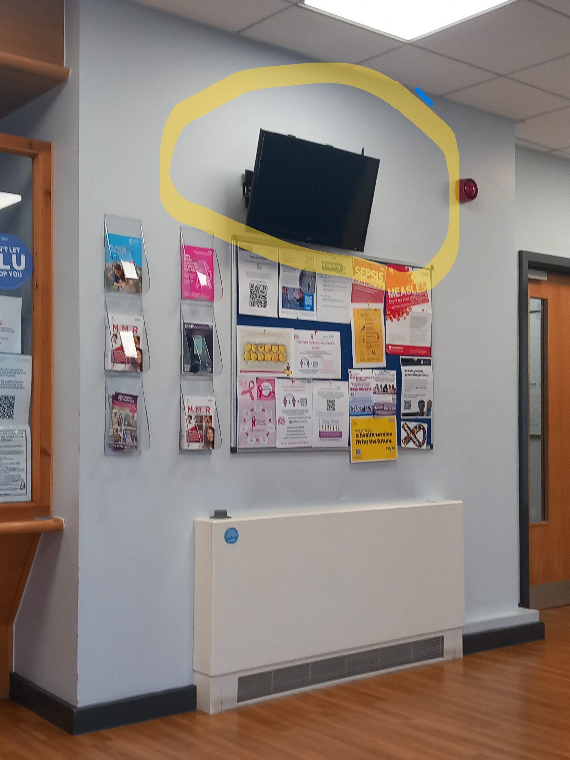
Missing how to get online
TV screen switched off
Cluttered noticeboards
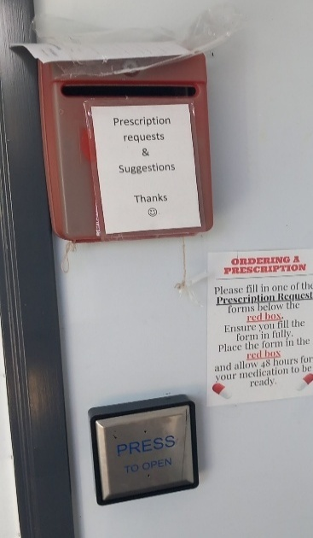
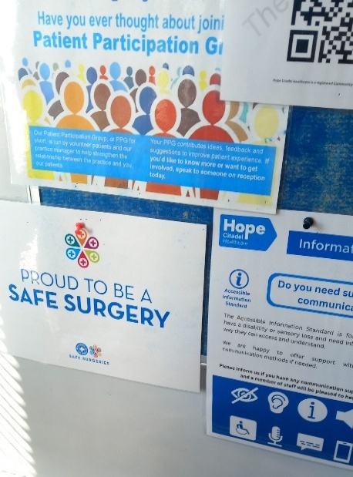
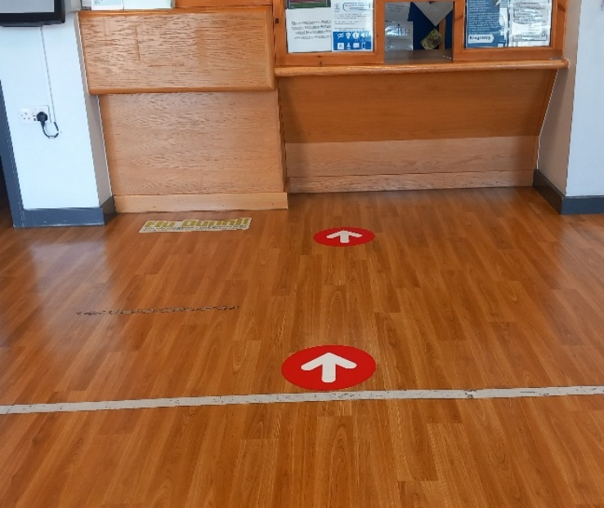
No privacy at reception
Prescriptions’ box
PPG poster
Observations:
- The practice is located near Morrison’s supermarket, Rochdale, with free parking and a tram stop behind the building; the nearest pharmacy is inside the supermarket.
- Access is good with a ramp and wide automatic doors.
- The waiting room was clean and tidy with adequate seating. However, reception lacks privacy—conversations could be overheard, and there is no “stop and wait” sign to keep patients back.
- During the visit, three patients used the self-check-in screen and four spoke with the receptionist.
- The patient toilet was in good condition at 10 a.m.
- The reception area contained a range of health and community leaflets, but noticeboards were a little disorganised with no themed boards. No patients were looking at them.
- A repeat prescription box at the entrance doubles as a feedback box; prescriptions can also be ordered online.
- The waiting-room TV/monitor was switched off.
- The Patient Participation Group (PPG) is being reinvigorated. Minutes are online. At the last meeting, members suggested sharing staff achievements, which are now displayed on noticeboards.
- A PPG meeting is scheduled for October 2025. New patients are given PPG information at their first GP appointment.
- The practice runs patient engagement events such as Macmillan coffee mornings, well-woman sessions, and digital access support. The team hopes the PPG will help strengthen patient relationships and promote digital NHS services.

Recommendations and Practice Response
 | Healthwatch Rochdale Recommendation  September 2025 | The Kingsway Practice  Name & position of responder | Update/Actions/Further comments  Date:
 | To install "Please Wait" signs at reception to improve privacy as patients check in. | Lauren Corner senior practice manager | There is a line not to cross on the floor that is worn admittedly so we have replaced it and added stickers to the floor advising patients where to wait to give privacy to patients. There is also a private room attached to the reception on the right with a window to the receptionist where patients can speak privately to members of the team. This is used frequently.
 | To ensure waiting room TV is on to maximise patient messaging opportunities. | Lauren Corner senior practice manager | This does not work. I believe CCG paid for licences and it ended. I have asked CCG who the contract was with and could we get a licence to no avail. We will take the Television down as no licence and cannot be used due to age of the tv. Would be great if any funding could be sourced to help purchase a new television.
 | Ensure the waiting room TV is switched on to promote patient communication, providing key information, health advice, and signposting to services. | Lauren Corner senior practice manager | As above
 | Display a “You Said, We Did” board in the waiting area to highlight patient feedback and the improvements made in response. | Lauren Corner senior practice manager | This work is ongoing – difficult with staffing levels to stay on top of boards. We had our wellbeing coach for PCN take over but due to her workload can no longer commit. PPG members were asked but no response. We will strive to organise going forward.
 | To theme the noticeboards and add large size headers on each noticeboard in the main patient languages. | Lauren Corner senior practice manager | Multiple posters in multiple languages. We have now added headers.
 | To display PPG flyers at the reception desk to raise awareness and encourage membership. | Lauren Corner senior practice manager | They are in welcome packs, on our website, offered in new patient health checks, leaflets in waiting room and available at reception.
 | Promote digital access by adding clear calls to action on the “Get Our Help Online” banner, including website links, NHS App details, and QR codes. | Lauren Corner senior practice manager | Our website is maintained by an external company that meets NHS guidance. We can however offer suggestions. We have multiple QR codes in reception and links to the NHS app. All of our staff have been trained to support patients getting started and downloading the app. We also offer a room to Kashmir Youth Project who are onsite every Monday and support patients digitally.
 | To share report findings at next practice PPG meeting |  | Findings were discussed we the PPG. We had 2 attendees. One of which offered to help patients at a digital drop in but unfortunately didn’t arrive on the day.

Appendix



Healthwatch Rochdale
Tel 01706 249 575
info@healthwatchrochdale.org.uk
www.healthwatchrochdale.co.uk







© Healthwatch Rochdale LTD 2025.
Registered Company Number: 08429721
We confirm that we are using the Healthwatch Trademark (which covers the logo and Healthwatch brand) when undertaking work on our statutory activities as covered by the licence agreement.
If you require this report in an alternative format, please contact us as above.

